iLoc8 – High Level Design

version 0.2 draft

# References

[1] EPT - iLoc8 Design Architecture – v7.pptx

[2] iLoc8_Package_SRS_vX10.doc

# History

|  |  |  |
| --- | --- | --- |
| **Date** | **Version** | **Changes** |
| 2016-10-20 | X01 | Created. Added General Architecture, Overview |
| 2016-10-24 | X02 | Added Server Application |

# Table of Contents

1References 1

2History 1

3Table of Contents 1

4Introduction 2

4.1Assumptions 2

4.2Overview 2

5Application Design 3

5.1Server Application 3

5.1.1Components Overview 3

5.1.2APIs Overview 5

5.1.3Component Descriptions 6

5.1.3.1Core 6

5.1.3.2Media Store Adaptor 6

5.1.3.3Event Storage Adaptor 7

5.1.3.4SMS Adaptor 8

# Introduction

This document provides a high level design of the iLoc8 application.

## Assumptions

The iLoc8 product consists of:

* The server application
* A REST API for writing clients for the server application
* One sample application for each targeted platform – Web, iOS, Android
* A documentation of the API and server installation

## Overview

The product in a few phrases is: The Caller has a phone audio discussion with the Agent. After mutual agreement, discussion is upgraded to have a data and video channels. iLoc8 starts after this upgrade, and offers the following features:

* Data channel with:
  + Automatic upload of Caller's location and device battery percentage
  + Manual upload of photos, videos, and Caller's address
  + Negotiating and managing the Video channel
  + Text Chat
* Video channel for a video conversation

The general architecture of the solution is shown in Figure 1.

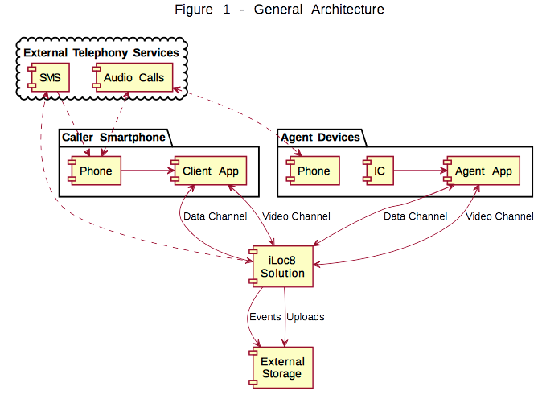

This document provides a high-level view of:

* The components involved, and their interactions
* SDKs and APIs involved

It addresses the following concerns:

1. Extensibility: Support for adding features not part of the current plan
2. Modularity: Ability to use different modules for the same functionality at implementation time (or runtime?)
3. Scalability and Performance
4. High-Availability, Fail-over
5. Security

# Application Design

## Server Application

### Components Overview

The server-side components are shown in Figure 2.

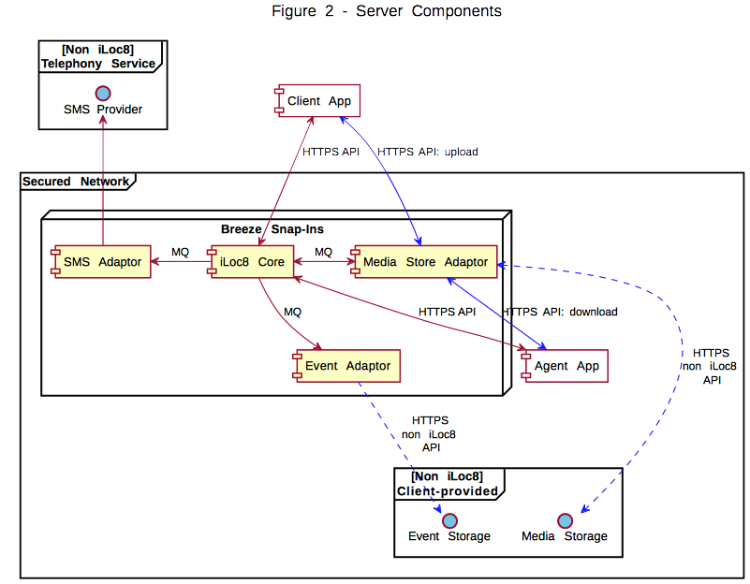

In this figure, the following conventions are used:

* Yellow Box: Server Component of iLoc8 Solution
* White Box: Client Component of iLoc8 Solution
* Blue Item: Non-iLoc8 component/interface
* Blue Arrows: only upload and download traffic
* Acronyms:
  + MQ: Messaging Queue

The iLoc Core component performs the main functionalities of the server. Each other component has a well defined role. All components are described in a section below.

The server components communicate with each other by means of a Messaging Queue. TBD: upload support?

The server components communicate with the client components and the non-iLoc8 components via HTTPS, with the only exception of SMS Provider for which communication type will be determined later.

### APIs Overview

The iLoc8 server exposes a REST API for interacting with it. The client applications are built upon this REST API.

This REST API has two components:

* Caller API
  + Upload API
* Agent API

Both APIs are exposed by iLoc8 Core.

The Caller API also includes an API for uploads, that is provided directly by the Media Store Adaptor, with control from iLoc8 Core. Figure 3 depicts this.

For the Caller, the iLoc8 Core also exposes an API for loading the Web version of the client application.

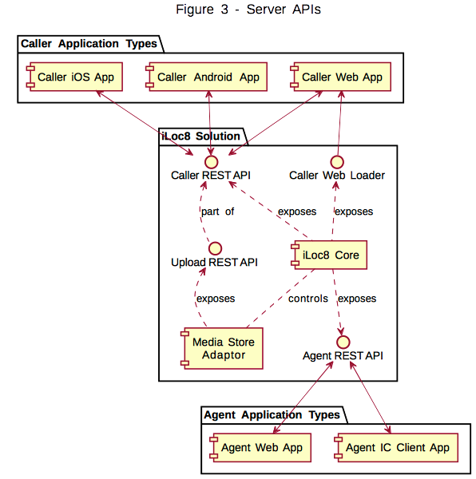

### Component Descriptions

#### Core

The iLoc8 Core is the main component of the server. Its roles are:

* Create, maintain, and delete sessions between Caller and Agent
* Establish data channel with Caller and Agent for Location & Battery Status, Manual address inputs, Text Chats
* Negotiate Media Store File Transfers with both parties
* Negotiate Video Channel between Caller and Agent
* Serve Web Client Single-Page App to the Caller
* Supervise uploads and downloads from the Media Store
* TBD: Keep session sharing with other Cores

Figure 4 shows Core's inputs and outputs. Blue arrows represent inputs. Red arrows represent outputs.

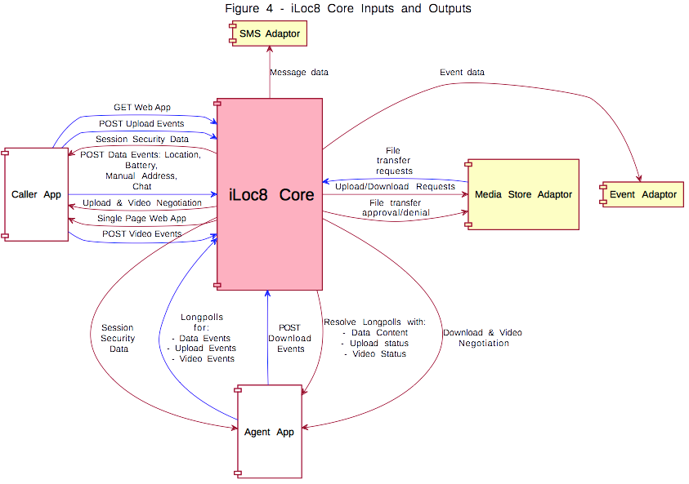

#### Media Store Adaptor

The Media Store Adaptor wraps-up accesses to the Customer-provided Media Storage. Its functionalities are:

* Perform file uploads directly from the Caller
* Perform file downloads directly to the Agent
* Get approval from Core for each file transfer

Figure 5 depicts its inputs and outputs. Arrow color codes are the same as for Core, plus: Green arrows represent communications done with parties outside of the iLoc8 solution.

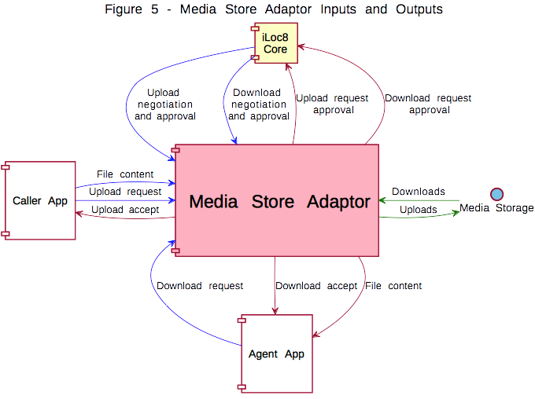

#### Event Storage Adaptor

The Event Storage Adaptor posts events to Customer's Event storage.

It's input and outputs are shown in Figure 6.

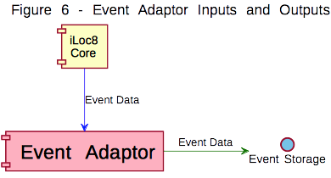

#### SMS Adaptor

The SMS Adaptor sends SMS's to a phone number.

